1st Global Ocean Decade Planning Meeting, Copenhagen, Denmark, May 13-15, 2019
Kerry Howell
University of Plymouth, UK
I would like to share with you my reflections on the first global Ocean Decade planning meeting. DOSI and deep-sea biology were out in force with Elva Escobar, Lisa Levin, Harriet Harden-Davies, Me, Alex Rogers, Paul Snelgrove and Riccardo Serrao Santos in attendance to name but a few (there were more!).
The meeting was spread over 3 days. On day one different panels outlined the identified societal outcomes (SOs) for the Decade, largely repeating information given in the road map but offering personal perspectives on it. On day two we were split into working groups with different groups focusing on different SOs. I attended the “predicted ocean” and “sustainably harvested and productive ocean” groups in the morning and afternoon respectively. Each group was asked to consider the knowledge gaps and key science questions under each theme, as well as to identify existing initiatives relevant to addressing these gaps and questions. We were also asked to discuss the role of some of the identified cross-cutting themes in addressing science questions. On day three we heard reports back from each of the SO working groups summarising the discussion had the previous day. We then had a series of panels dealing with the following themes: capacity building and technology transfer, partnerships and financing, data and information sharing and knowledge exchange, and communicating the decade; before a final wrap up session.
I feel that between all the deep-sea people there, we were able to ensure that deep-sea biology was highlighted as an important part of the Decade. The deep sea was certainly highlighted in a number of the working group summaries on the last day, so that is positive. Discussion over the three days was very high level as might be expected from the first Global Planning Meeting. There were some key messages that came across that I can share:
1. The Decade is (and will be) whatever we make of it. It is a grass roots initiative and it is on us to develop research programmes.
2. There is no special pot of cash to pay for new programmes. The Decade brand could help attract philanthropic funding, and there is the potential for private-public partnerships, partnering with industry, but essentially there is no UN level cash. Individual nations may make money available but you would need to speak to your own national representatives about that.
3. It is “the decade of ocean science for sustainable development” so it is important to recognise and identify how any proposed research contributes to sustainable development. It will also be important to include other disciplines in programmes, for example environmental economists, social scientists, etc as these are the folks who connect the research to people.
4. Fairness, equity, inclusivity, and capacity development are all central to the decade plans.
5. It is desirable to work with existing initiatives where possible, for example Seabed 2030 and GOOS were both mentioned.
6. Seabed 2030 is not just about bathymetry mapping it is all mapping (biological, chemical, human use, ecosystem services etc), GOOS is actively looking to include more biology.
7. Collating and making use of existing data is good, for us this could include things like interpreting old video / image data so we know what we have before we collect more, mining historical expedition data, etc.
8. Open access and open data sharing is also a must.
9. The Sustainable Development Goal 14 is “Life below water” so biology is central to the Decade, even though at present there is a lot of focus on physical oceanography and climate.
So in summary I think the Decade does represent a golden opportunity for our community to do something special. To think bigger and on longer timescales of research than we have allowed ourselves to in the past. To reach out to new partners and regions that have not traditionally engaged in deep-sea science. To think creatively about how we study the deep sea, and how new technology might help unlock new lines of research, while cheaper technology might help bring more nations into the field. But ultimately, to expand our knowledge of this amazing ecosystem we are all privileged to study.
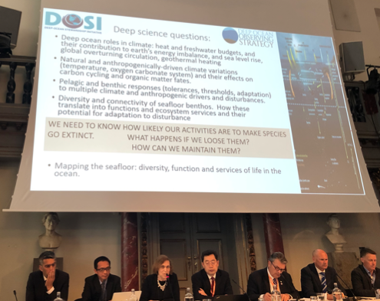
Lisa Levin presents DOSI science questions during meeting.

