13 November 2023

Report
DOSI participation in the Third part of the 28th session of the International Seabed Authority

Overview
The third part of the twenty-eighth session of International Seabed Authority (ISA) was held in Kingston, Jamaica from 20th October to 8th November, and involved the meeting of the Council. DOSI participated in person and was supported by a team of experts who participated online.
Items on the agenda of this ISA Council and Assembly session with relevance for DOSI included:
- Draft regulations on the Financial Terms of a contract
- Draft regulations on the Protection and Preservation of the Marine Environment
- Draft regulations on Inspection, Compliance, and Enforcement
- President’s text
- Report of the Legal and Technical Commission

Incidences report:
During the first day of the council, a 5.4 earthquake was registered with epicenter in the vicinity of Kingston. The Kingston conference center was evacuated, and the meetings postponed until the next day. A detailed report with details on DOSI reactions and management is included in Annex II

DOSI Delegation participating in person
Patricia Esquete (Co-lead)-Heard of delegation.
Beth Orcutt
Stephen Cody

DOSI Minerals WG experts supporting other delegations
Matthew Gianni (Deep-Sea Conservation Coalition)
Sabine Gollner (Co-lead) (Netherlands)

DOSI Minerals WG experts supporting virtually
Jesse van der Grient (Co-lead)
Catherine Blanchard
Stephen Cody
Laisa Branco Coelho Cavalcante
Elva Escobar Briones
Kristina Gjerde
Aline Jaeckel
Kerstin Kröger
Lisa Levin
Hannah Lily
Anna Metaxas
Beth Orcutt
Samantha Robb

DOSI Actions

Interventions and textual proposals
DOSI actively intervened in the discussions by delivering a total of 12 interventions (Annex I), that included scientific and expert opinions on how to ensure high environmental standards and the reflection of independent and robust science in the regulations. The interventions delivered can be found on the ISA website as well.
Our work was mentioned in interventions or had our interventions supported by: PEW Charitable Trusts and the Federal States of Micronesia. Interventions were delivered in English or Spanish.

Attendance at side events
DOSI attended the following official ISA side event that took place during the meetings of this session:
Environmental Impacts: Addressing Concerns with Data – NORI
DOSI asked pertinent questions during the Q&A of the event, and Members of the Council followed up on these questions at a later stage, with regards to general impacts and the relevance of biodiversity studies.

Informal meetings held with other delegations
Several informal meetings were held with various State delegations, including Costa Rica, Germany, Ireland, Norway, Spain, UK. Meetings included topics such as aspects on marine ecosystems including the protection of the marine environment, biodiversity, marine genetic resources, thresholds, plume impacts, baseline data, and about DOSI as a network of ocean experts. In addition, DOSI had informal meetings with other Observers (DSCC, Greenpeace, Pew Charitable Trust, AIDA, Oceans North, The Ocean Foundation, IUCN) to discuss the course of the negotiations, share ideas, and coordinate interventions where possible. DOSI also held informal conversations with members of the Secretariat seeking future engagement, coordination, and strategies for upcoming ISA workshops.
Meetings were on several occasions followed up by providing additional information, including DOSI policy briefs and information sheets, and scientific articles.

Gallery
Source: Photos by Earth Negotiations Bulletin
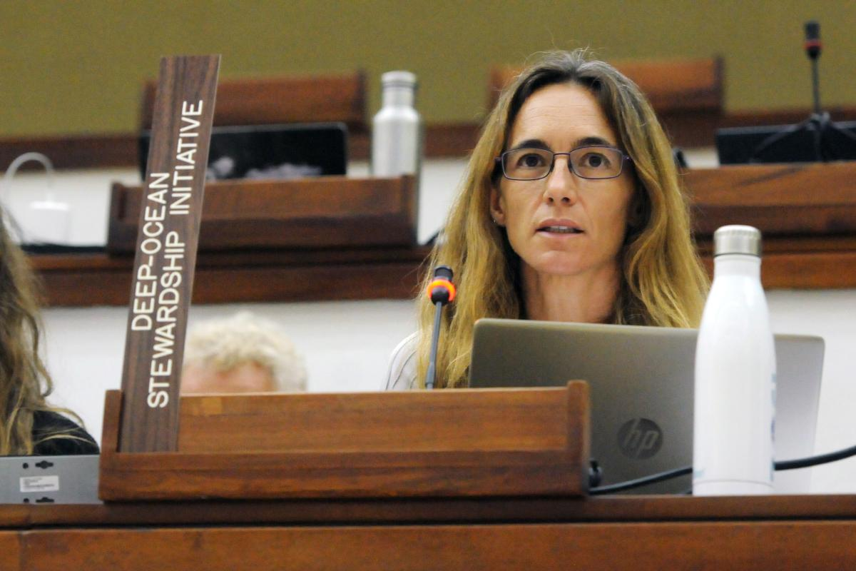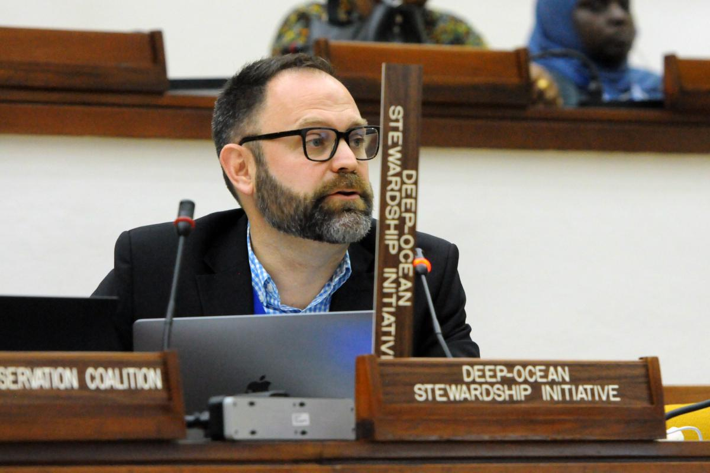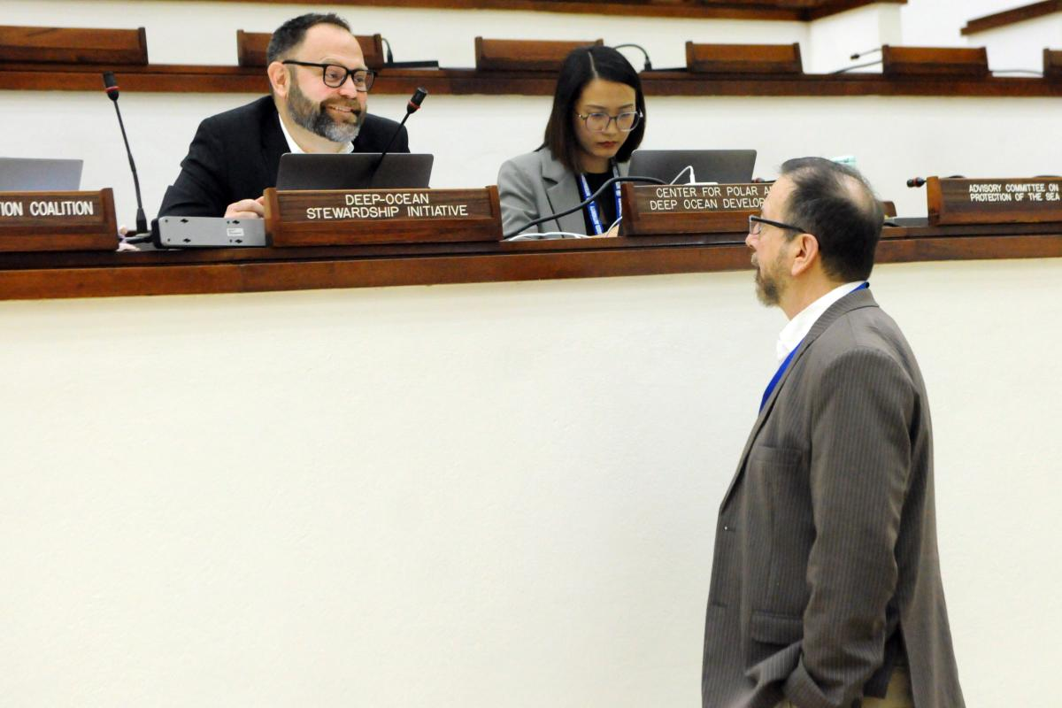

ANNEX I. Interventions

DOSI intervention #1
Informal Working Group on the Protection and Preservation of the Marine
Environment

DR49 - pollution control - Delivered by Patricia Esquete on 1.11.2023

Thank you Madam Facilitator.
Since this is the first time DOSI takes the floor, we would like to congratulate you on the progress made in this Working Group.

DOSI would like to support PEW fully on this regulation. Regarding greenhouse gases , there is indisputable scientific evidence on the impact of greenhouse gases emissions on oceans, including warming, deoxygenation and ocean acidification and more generally the role of the ocean in climate regulation. We believe that a reference to greenhouse gas emissions as part of the pollution control provisions in the regulations is therefore essential.
We also agree with many delegations who support the retention of the reference to underwater noise considering the impacts of noise on marine species, as demonstrated by the robust scientific evidence.

Thank you.

DOSI intervention #2
DR51 - compliance with the EMMP – Delivered by Patricia Esquete on 01.11.2023

Thank you, Madam Facilitator.

With the current technology available and ongoing improvements, sharing environmental data from ships to shore is easy and accessible. In addition, it is of vital importance that these data are shared, so that independent experts can provide additional assessments of potential impacts. Last, data from these areas are scarce, and new data can greatly improve our understanding of the natural environment, which is greatly needed for modeling purposes and reducing uncertainty.
Therefore, we support the inclusion of ‘publicly’ in paragraph 1a; we support that the data are made available on a real-time basis; we support the implementation of FAIR principles; and we strongly recommend the removal of ‘where possible’ so as to promote the use of all available technology, possibilities and opportunities for sharing data.

Thank you, Madam Facilitator.

DOSI intervention #3
DR 59 - Closure Plan – Delivered by Patricia Esquete on 01.11.2023

Thank you Madam Facilitator,

In regard to paragraph 1bis(d) and the notion of returning mine site to its natural state, DOSI would like to reiterate that it is important to recognise that the ores that would be mined are the habitat or living places for many deep-sea organisms, that these living places will not come back until after millions of years once removed, and that we are as of yet not capable to mimic this habitat
Restoration efforts in the deep ocean are challenging, and feasibility should be re-considered; We know that biological and ecological processes in the deep sea are slower than in other realms, and impact experiments have shown little recovery of ecosystem functions and processes after decades. The very few restoration experiments that are currently being carried out will only yield the first results after years, maybe decades from now. Hence, not only is the feasibility of restoration actions in the deep sea in doubt, but also it is unlikely that such processes will take place in our lifetimes. The impacts caused by habitat removal can be considered irreversible.
Thank you

DOSI intervention #4
DR 60 - Final Closure Plan: cessation of production – Delivered by Patricia Esquete on 01.11.2023

Thank you Madam facilitator,

Regarding paragraph 1bis, from our experience as scientific experts, allowing 90 days for reviewing a closure plan would be more adequate to allow for substantial and meaningful comments by experts who often hold multiple time commitments.

Thank you

DOSI intervention #5
Annex IV Environmental Impact Statement – Delivered by Patrcia Esquete on 02/11/2023

Thank you Madam Facilitator

Regarding Annex IV, the Deep-Ocean Stewardship Initiative welcomes many of the proposed revisions, and we thank you for your hard work to develop this Annex.DOSI will submit written comments on specific paragraphs. However, we have one general comment, and would also like to take a moment to clarify some of the comments we have heard during this discussion.

Regarding the introductory text of annex IV, DOSI would like to make a suggestion related to the clarity of language. As experts reviewing EISs, we note that clear and legible graphs and figures are paramount for the clarity of the statement as a whole. However, appropriate quality of such figures is not always evident, including in reports we have seen submitted to the ISA. We therefore suggest the inclusion of additional wording in paragraph 1(a), which would read as follows: “Be prepared in a clear language, including clear graphics and tables, and in an official language…etc” The aim is to ensure that data are presented in a way that allows relevant parties and stakeholders to engage in meaningful ways with the material.

Regarding paragraph 5.4, in response to some delegations’ interventions, DOSI would like to clarify that the focus should be on maintaining ecosystem functions that are imperative for climate regulation. That is biological processes that facilitate climate regulation.
Likewise, DOSI strongly recommends that para 4.6 about the incorporation and assessment of climate change effects is kept. The length of a contract covers several decades, over which climate change effects will become more and more apparent. Therefore, given that the EIS is part of a PoW, it should include climate change effects.

DOSI would finally like to reiterate its commitment to participate in public consultation and review of the EISs as much as possible in our capacities as experts. DOSI stands ready to assist the Council and its member States.

thank you Madam Facilitator

DOSI intervention #7
DR44bis - regional environmental management plans & 45 Development of Evironmental Standards and Guidelines – Delivered by Patricia Esquete on 02.11.2023

Thank you Madam Facilitator,

Our apologies, DOSI also seems to have missed the opportunity to talk to DR44bis, so we will first address that and then move to DR45

With regards draft Regulation 44 bis, DOSI emphasises the importance that the Council considers a Plan of Work only once a REMP is in place for the applicable area. DOSI notes the inclusion of “without undue delay” in paragraph 2 and highlights that this should not lead to a REMP being hastily adopted because a Plan of Work has been submitted. All REMPs should be robust, and contain a procedure to allow them to be reviewed and updated at regular intervals or on a regular basis.
DOSI highlights that it is necessary for the standardised approach to REMPs to be finalised for adequate REMPs to be developed in an appropriately inclusive manner, and that include clear overarching strategic environmental goals and objectives. Given that these goals and objectives will define harmful effects and serious harm it is hard to see how the LTC or ISA could consider a plan of work without them. These standardised documents should be agreed and applied prior to finalising a REMP for any area for which a Plan of Work is submitted to ensure consistency between REMPs of different areas.

Now for DR45

DOSI suggests including a provision for a timeline for the review of environmental standards. The increased availability of environmental baseline data that ought to be collected during the Exploration Contract Periods, will provide crucial new information about ecosystem structure, functioning and services. Ongoing research will also provide increased confidence levels on thresholds for various impacts. In addition, with the ongoing climate change emergency (as well as the global pollution and biodiversity crises), it is likely that environmental conditions will change due to climate change and phenomena previously not observed may occur which in themselves might affect those conditions, and this in turn may require review of ISA Standards and thresholds. We therefore recommend the addition of a new paragraph 6 to define the timeframe for regular review of the standards.

In addition, DOSI suggests removing ‘including restoration measures’ in paragraph 2(d), given that there is an established mitigation hierarchy that includes restoration.

Thank you Madam Facilitator

DOSI intervention #8
DR46ter: EMMP – Delivered by DOSI on 02.11.2023 by Patricia Esquete

Thank you, Madam Facilitator.
DOSI would like to make 2 comments regarding DR46ter.

First, in paragraph 3bis regarding supplementary monitoring, DOSI wishes to support Costa Rica regarding maintaining the requirement for the monitoring to be conducted by ‘competent independent experts’. As the supplementary monitoring is intended to ensure the proper application of the contractor’s environmental monitoring programme, it would need to be conducted by independent experts for a fair and impartial assessment to be conducted.

Second, in paragraph 4, and elsewhere in the text of the regulations, DOSI suggests removing ‘where practicable’ before the word real-time. The current state of technology is that various data types, using a multitude of different equipment, can be collected and transmitted in real time. As scientists, we continue to be amazed how quickly this field is evolving and how feasible it is becoming to transmit and share data from ships. Therefore, “where practicable” is unnecessary, and may even cause confusion. Removing it will provide clarity to the text.

Thank you Madam Facilitator.

DOSI intervention #9
DR47 - environmental impact assessment process- Delivered by Patricia Esquete on 02/11/2023

Thank you, Madam Facilitator.

DOSI supports the joint proposal submitted by the United Kingdom, Germany, and others on restructuring the EIA process in section 2. DOSI has the following additional suggestions:

First, as noted by Belgium, the current revised text should indicate that an EIA must be conducted in accordance with environmental goals and objectives associated with the corresponding environmental thresholds. Such an inclusion could be added to paragraph 2 and 3 of DR47alt, for example. Further, it could be included or considered in the procedures of an EIA as outlined in paragraph 4 of DR47alt for the assessments of mining impacts.

Secon, DOSI welcomes the inclusion, in DR47alt para 4(b)(i), that underwater cultural heritage, residual impacts, cumulative impacts, including other existing and foreseen mining operations, other activities, and natural phenomena should be considered at the stage of assessing environmental impacts, and support Mexico in suggesting the inclusion of synergistic impacts. DOSI suggests that “climate change” is added to this list as it will have an impact on ocean environments and biological communities. For example, consideration is required of how the impacts of climate change may affect oceanographic currents and sound propagation, changes distribution of planktonic and mobile species populations in and above contract areas, or how climate change may exacerbate the effects of mining as these impacts are not necessarily additive, but can be multiplicative.Thus, the consideration of the impact of climate change is vital and should apply throughout the regulations.

Third, DOSI suggests that the effects on ecosystem services are assessed as part of the EIA, and we take the opportunity to remind the council that there is a lack of data to estimate the cost to ecosystem services in the deep sea, as highlighted by a report from the ISA (ISA/2023/OEMMR002). This work ought to be a high research priority.

We note that these comments on DR47 and DR47alt also apply to DR47bis, DR47ter and DR48. We will not repeat ourselves when we are discussing those regulations, but we will submit our comments for these regulations in writing.

Thank you madam Facilitator

IWG Institutional matters

DOSI intervention #10
DR92bis - Publication of environmental data and information – Delivered by Stephen Cody on 07.11.2023

Thank you co facilitators,

DOSI supports the inclusion of DR92 bis, and we stand ready to help with or provide advice on the relevant Standards and Guidelines to ensure that environmental data is appropriately defined (as we do not see a definition in the Regulations); and that the database meets the FAIR principles, which is a global standard the scientific community is following. FAIR is an acronym that covers Findability, Accessibility, Interoperability, and Reuse

We also suggest that the environmental data is defined here to include, at a minimum, all physiochemical and geological oceanography and biological information that needs to be collected as per the EIS and monitoring plan, but that additional data that may be collected is also welcome. DOSI will submit a textual proposal towards an appropriate definition for environmental data.

Thank you co-Facilitators

President¡s text

DOSI intervention #11
Section III Technical information – Delivered by Stephen Cody on 08.11.2023

Thank you, Mr. President.

Regarding Paragraph 20bis in Section III, DOSI would like to remind the Council that other Marine Users can potentially have activities in the Area under application, and these should be likewise indicated here. For example, there may also be infrastructure from Marine Scientific Research activities within the area. Therefore, this section should also require the contractor to provide documentary proof of any measures to reduce the risk to the scientific infrastructure. Likewise, there may be infrastructure related to fishing activities present in the area.

In short, DOSI recommends including all relevant marine users in this paragraph, in requiring Contractors to identify potential conflict and how it will be managed to reduce risk to other users.

Thank you, Mr. President.

DOSI intervention #12
Annex X - Standard clauses for exploitation contract – Delivered by Stephen Cody on 8.11.2023

Thank you Mr President,

DOSI strongly supports the inclusion in 4.1, regarding the limitation of spreading adverse impacts to the Contract Area only. Allowing impacts to extend outside of a Contract Area risks impacts spreading to other Contract Areas, and this would be especially concerning if those impacts affect their PRZs or IRZs, thereby affecting these crucial monitoring tools, which contractors should use to monitor for natural variability and mining impacts. It will become especially difficult to generate useful data or conclusions on monitoring from these areas should there be additional mining impacts originating from other Contract Areas.

Thank you Mr President.

Annex II: Earthquake report
On 30 October 2023, part III of the 23th session of the meetings of the Council started with no incidences a few minutes after 10:00 am local time. At An earthquake of 5.4 M at a depth of 10 km occurred in the Portland Parish area (northeast Jamaica) on 30 October at 15:57 UTC (10:57 local time) and was felt in the conference center. A few minutes after, the building was evacuated and all delegates, members of the Secretariat and other personnel remained in the parking lot waiting for further information and instructions.

At approx. 11:45 the session was resumed. Some delegations suggested to interrupt the meetings until the building could be properly inspected and the session was postponed until 15:00.
The DOSI delegation went back to the hotel.
At 14 h we received information that WEOG concluded to not return to the building until at least next day.
At 14:33 an aftershock of 4 occurred while we were in the hotel. We were evacuated.
At approx. 16h our delegation was informed that five country delegations had received orders from capitals to immediately leave the country and return home.
The ISA secretariat decided to postpone the meetings until the next day.
The DOSI Minerals leads passed all the available information to the delegates on site, in transit to Jamaica, or with plans to travel in the upcoming days. Leaving, remaining in the country, or travelling or not the upcoming days were personal decisions of our delegates. The leads assisted with organizing evacuations and/ or contacting the travel agency as necessary. As a result:
- 1 DOSI delegate left Jamaca the next day.
- 2 DOSI delegates that were in transit to Jamaica decided to return home.
- 1 DOSI delegate remained on site until the end of the session.
- 1 DOSI delegate decided to travel to Jamaica for the second week of the meetings, arriving on… and staying until the end of the meetings.
The leads also reported to DOSI executive.

Additional documents
- Statement by the Secretary-General of the International Seabed authority, H.E. Mr. Michael W. Lodge on the status of the situation in the Jamaica Conference Center post-earthquake
- Statement by the Government of Jamaica to ISA Council re: Earthquake

Future actions
The leading team decided to produce an emergency protocol document to be filled up before every upcoming ISA meeting. It will include relevant information, passports, and emergency contacts of all our delegates on site. The document will be shared with the team online and the DOSI executive, so that they can assist in case of emergencies.

