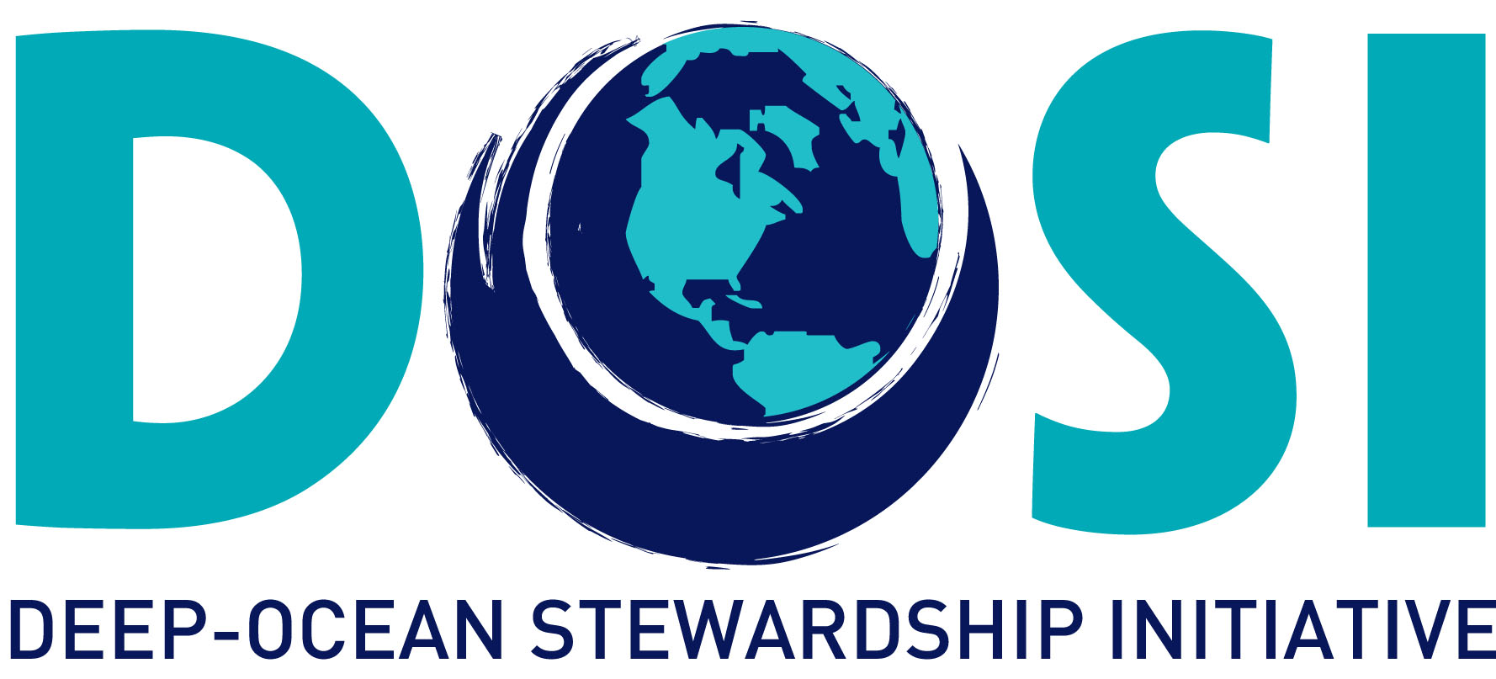

DOSI Minerals Working Group Activities 2013 to 2017

- DOSI Guidance and Recommendations
Nov 2017 DOSI commentary: Draft Regulations on Exploitation of Mineral Resources in the Area. Link to ISA document.
May 2017 DOSI produced an opinion piece for The Environmental Forum of the Environmental Law Institute
Jan 2017 The Discussion Paper on the Draft Regulations for Mineral Resources in the Area (Environmental Matters) can be found on the ISA website. Members of the Minerals WG met for the EREGS workshop to examine the documents (San Diego, USA). The workshop participants produced a Letter to the ISA and a Synopsis
Oct 2016 DOSI commentary: Draft Regulations on Exploitation of Mineral Resources in the Area (ISBA/Cons/2016/1)
Oct 2016 DOSI publication: Levin et al. (2016) Defining “Serious Harm” to the Marine Environment in the Context of Deep-Seabed Mining. Marine Policy, pp. 245-259
Oct 2016 DOSI commentary on ISA review (Article 154 UNCLOS)
Oct 2015 DOSI commentary prior to publication: Secretariat of the Pacific Community (SPC) Regulations and Recommendations ‘Standards for scientific research and mineral exploration and exploitation’
May 2015 DOSI commentary on ISA report to stakeholders ‘Developing a Regulatory Framework for Mineral Exploitation in the Area’ (ISBA/Cons/2015/1). Link to review.
May 2014 DOSI recommendation letter to the ISA on Scientific Research
May 2014 DOSI commentary to the ISA stakeholder survey

- Workshops and Symposia sponsored or led by DOSI:
Jul 2017 DOSI attended the ISA 23rd Session, hosting a side-event. The DOSI delegation consisted of Kristina Gjerde, Lisa Levin, Verena Tunnicliffe, Judith Gobin, Amber Cobley and Torsten Thiele (Kingston, Jamaica)
July 2016 DOSI attended the ISA 22nd Session (Kingston, Jamaica)
Aug 2015 DOSI Planning Workshop (Aveiro, Portugal)
Mar 2014 DOSI Workshop on defining significant impact & performing cumulative impact assessment (San Diego, USA)
Feb 2014 DOSI Special Session: Deep Ocean Industrialization: A New Stewardship Frontier (AAAS, Chicago, USA)
Mar 2013 DOSI Inaugural Workshop (Mexico City, Mexico)

- Workshops and Symposia attended by DOSI representatives:
Oct 2017 JPI Oceans ‘Ecological aspects of deep-sea mining’ Meeting. Report.
Sep 2017 Underwater Mining Institute Annual Meeting (Berlin, Germany)
Sep 2017 ISA Workshop on the Design and Monitoring of Impact Reference Zones and Preservation Reference Zones (Berlin, Germany) DOSI Report
May 2017 Deep-Sea Mining Summit(London, UK)
Mar 2017 Workshop: ‘Towards an ISA Environmental Management Strategy for the Area’, jointly organized by the German Environment Agency (UBA), the Federal Institute for Geosciences and Natural Resources (BGR) and the ISA and supported by the Institute for Advanced Sustainability Studies Potsdam (IASS) (Berlin, Germany). Link to synopsis.
Jul 2016 SEMPIA Workshop (Azores, Portugal)
Jul 2016 Workshop on Enhancing Stakeholder Participation and Transparency in the ISA Process (Ocho Rios, Jamaica). Link to report.
Jul 2016 DOSI awarded Observer Status at the International Seabed Authority (Kingston, Jamaica). Link to blog.
May 2016 Griffith Law School and the ISA Workshop on Environmental Assessment and Management for Exploitation of Minerals in the Area (Queensland, Australia). Link to report.
Oct 2015 WEF/Rockefeller Foundation/RESOLVE Workshop on Deep Sea Mining
(Bellagio, Italy)
Jun 2015 EcoDeep-SIP Workshop: ‘The crafting of seabed mining ecosystem-based management: Assessing deep-sea ecosystems in the Pacific Ocean’ (Tokyo, Japan)
Jun 2015 IMO and GESAMP Workshop on Deep-Sea Tailings Placement (Lima, Peru)
Jun 2015 Towards the development of a Strategic Environmental Management Plan for deep seabed mIneral exploration & exploitation in the Atlantic basin (SEMPIA) (Azores, Portugal)
May 2015 Workshop on environmental standards for deep-sea mining (Tromso, Norway)
May 2015 Workshop: ‘From Seafloor Hydrothermal Systems to the Sustainable Exploitation of Massive Sulfide Deposits: Myths & Realities of the Deep’ Sea (Bergen, Norway)
Apr 2015 Symposium on deep-seabed mining & Pacific cultures (Honolulu, USA)
Oct 2014 IASS Workshop on Ocean Governance (Potsdam, Germany)

- Capacity Development
2016 DOSI co-led a Workshop on capacity building concerning phosphate mining impacts, co-funded by ISA (Namibia)
2015 SOPAC 3-month traineeships for two Pacific islanders to learn techniques for conducting environmental baseline studies and biodiversity evaluation of deep-sea polymetallic nodule ecosystems (Honolulu, USA)

