SUSTAINING DEEP-SEA BIODIVERSITY IN AREAS BEYOND NATIONAL JURISDICTION.
THE DEEP-OCEAN STEWARDSHIP INITIATIVE (DOSI)
Report to the Arcadia Fund. 1st October 2019
(Reporting period 1st August 2018 to 31st August 2019)

Maria Baker (University of Southampton, UK), Harriet Harden-Davies (University of Wollongong, Australia) with input from DOSI Executive and Working Group Leads
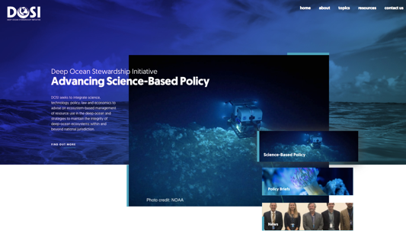

CONTENT
EXECUTIVE SUMMARY
PROGRESS - ACTIVITIES, OUTPUTS, OUTCOMES AND IMPACT
- DOSI Organisation/Governance
- DOSI activities - BBNJ Process
- DOSI activities - Deep Seabed Mining
- DOSI activities – Climate Change
- Other DOSI activities
- Additional funding secured
- Future activities September 2019 - August 2020
- Are we on track?
- Impact

EXECUTIVE SUMMARY
Box 1: DOSI 2019-20 Highlights
- DOSI Governance documentation finalised and online
- Improved DOSI communications including new website and Instagram
- Increased membership
- BBNJ IGC1,2 & 3 – 7 policy briefs, 10 side-events, numerous interventions & side-meetings
- BBNJ stakeholder commentary submissions
- BBNJ-related workshops x 6
- ISA – 3 policy briefs, 2 side-events, numerous interventions and side-meetings
- ISA stakeholder commentary submissions
- Deep seabed mining-related workshops x 9
- New publications x 9
- DOSI Day
- DOSI Special Session at DSBS
- Capacity development activities
- Further funding secured for DOSI
- Numerous outreach activities
- Engagement with the UN Decade
The funding award from Arcadia Fund to the Deep-Ocean Stewardship Initiative has enabled continued, coordinated involvement of a wide variety of experts, predominantly deep-sea scientists, to engage with national and international policy processes in a way that is unique and essential at this critical time for the future of ocean biodiversity. Since our July 2018 report to Arcadia, our network membership has expanded, new governance has been established, comprehensive terms of reference and guidance documentation have been produced, approved and circulated, our internal and external communications have improved, and our Core Team and an ever-growing number of working group members are even more engaged in numerous DOSI activities (Box 1).

As a recap, the main thrust of our work under this grant concerns sustaining marine life in areas beyond national jurisdiction by providing expert input to both the negotiations for a new UN treaty on Biodiversity Beyond National Jurisdictions (BBNJ) and the International Seabed Authority (ISA) mining regulations to ensure that their outputs are fit for purpose and enforceable. DOSI is now a well-established UN observer and attends many events related to these issues, continuing to coordinate targeted scientific input to aid the formation of these high-level regulations. DOSI contributions come in the form of policy briefs, peer-reviewed papers, reports, books, meeting and workshop participation, UN and ISA side-events, interventions and presentations. DOSI members continuously work hard to build relationships across disciplines and sectors in order to establish a broad knowledge among all stakeholders of the key science/environmental issues and the latest scientific results that may influence the management of the deep ocean. During the last year, DOSI has also continued to raise awareness of climate change in the deep sea and is planning for and promoting the deep ocean as a key component of the upcoming UN Decade of Ocean Science for Sustainable Development.

Again this year, we have been successful in leveraging additional funds for DOSI activities to organize stakeholder workshops, produce technical reports, and to increase participation (including for developing-nation and early career scientists) in relevant meetings. Communication of important deep-sea research and stewardship matters across and beyond the network is an integral part of our work and, with a further increase in membership from a variety of stakeholders, and an injection of funding from Synchronicity Earth to improve and develop our communications strategy, we are now reaching further afield. This, along with the redistribution of funds from Arcadia to support the DOSI office for an additional day per week, allowed us to address and make significant progress on the challenges that we reported to Arcadia last year associated with administrative support, including communications. Finally, we continue to pay close attention to our policy engagement strategy, to ensure that our activities are policy relevant without being policy prescriptive, and take care not to stray towards advocacy.

PROGRESS - ACTIVITIES, OUTPUTS, OUTCOMES AND IMPACT
DOSI Organization/Governance
Following a thorough review during 2017/18, the DOSI Core Team (comprising Executive, Advisory Board and Working Group Leads) is now well-established, with a clear and transparent governance structure, guiding principles, terms of reference and roles and responsibilities. Explanatory documentation is now available on the DOSI website. The current Core Team are introduced on the “Who We Are” page of the website.

The DOSI Core Team decided to rationalize the existing DOSI working groups in July 2019. It was felt that the Policy, Capacity Development and Assessments group activities transcended all of the working group topics so they have been disbanded and activities incorporated into nine remaining working groups (BBNJ, Minerals, Climate Change, Fisheries, Deep-Sea Tailings Disposal, Oil & Gas, Deep-Sea Genetic Resources, Decade of Deep Ocean Science, New Technologies). In addition, a new group on Deep-Sea Debris and Pollution is in the process of being established to reflect the growing worldwide concern about these issues and a DOSI sub-group has been formed within the Fisheries working group to work towards a community consensus on the use of imagery for Vulnerable Marine Ecosystem designation.

DOSI continues to expand network membership, with an increase of 96 new members since July 2018 to 687 in August 2019 - exactly double the number of members we increased by last year. DOSI works closely with the INDEEP network, often sharing communications, and collectively this network is now comprised of 1248 members from 64 different countries, from a variety of disciplines (around 70% are scientists) and are ~50% female.

DOSI Activities – BBNJ Process
During this reporting period, the DOSI BBNJ working group has continued to deliver important input from the deep-sea community in terms of scientific and technical information to inform substantive discussions, as the first draft text of a new international legally binding instrument for the conservation and sustainable use of marine biodiversity in areas beyond national jurisdiction, under the UN Convention on the Law of the Sea, is prepared. There are currently 79 members associated with this working group, which provides a focal point for scientific expertise and network engagement on BBNJ issues.

During 2018, DOSI set the stage for facilitation of science-policy engagement at the negotiations, focusing on areas such as open access to scientific data and knowledge, inclusive technological innovation, and robust enforceable measures for biodiversity conservation. Our activities during this reporting period have been numerous and comprise sending delegations of deep-ocean scientists to participate in informal meetings, providing formal interventions, engaging with government delegates, submitting written input to the negotiations via policy briefs, and side-event presentations in collaboration with governments, Inter-Governmental Organisations (IGOs) and Non-Governmental Organisations (NGOs). The main activities of the BBNJ working group in this reporting period are listed below in chronological order:

July 2018
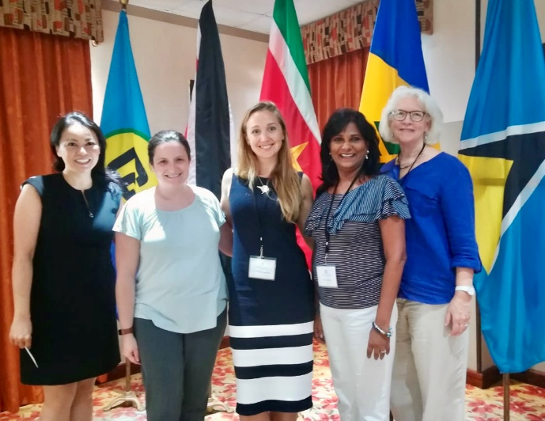
- CARICOM (Carribean Community) BBNJ Workshop (30-31 July, Belize). Harriet Harden-Davies (BBNJ WG Lead), Judith Gobin (DOSI Advisory Board member) and Kristina Gjerde (DOSI Executive) attended this workshop hosted by the Government of Belize, Pew Charitable Trusts and the High Seas Alliance. They raised issues of science collaboration, innovation and deep-ocean conservation. (Image: DOSI experts and colleagues at CARICOM BBNJ Workshop – From right to left: Hiroko Muraki-Gottlieb (IUCN), Nichola Clarke (Pew), Harriet Harden-Davies, Judith Gobin and Kristina Gjerde (DOSI))

September 2018
- DOSI participation in BBNJ IGC1 (Intergovernmental conference for the development of a new international legally binding instrument for the conservation and sustainable use of biodiversity beyond national jurisdiction under the United Nations Convention on the Law of the Sea, first session). DOSI facilitated scientific and technical input to the development of the BBNJ instrument. As BBNJ issues cut across a number of DOSI working group areas, this working group facilitates coordination and engagement across all DOSI-relevant areas. Wide consultation with DOSI network members via email and online meetings prior to IGCs are a fundamental part of the extensive preparations for DOSI working group leads. A point to note, the UNESCO Intergovernmental Oceanographic Commission quoted the DOSI Deep-Sea Fundamentals brief (listed below) in their opening statement, as did the Maldives on behalf of the Alliance of Small Island States who opened their intervention with a reference to the deep sea, likely a result of the DOSI submissions.
  - DOSI delegation: Harriet Harden-Davies (University of Wollongong, Australia), Jeff Marlow (Harvard University, USA), Paul Snelgrove (Memorial University, Canada) and Porter Hoagland (Woods Hole Oceanographic Institution, USA).
  - Policy Briefs: DOSI compiled and distributed four policy briefs:
    - Deep-Sea Fundamentals
    - Strategic Environmental Assessment
    - Climate and biodiversity beyond the limits of national jurisdiction
    - Sustaining biodiversity beyond national jurisdictions: The major science challenges
  - Side Events: Four officially sanctioned side-events were organized and co-organized through DOSI members:
    - The role of deep-sea research in technology transfer: DOSI, UNESCO-IOC, Maldives
    - Marine genetic resources: IUCN, Norway, Jamaica, DOSI
    - Exploring options for a scientific and technical committee: Pew Charitable Trusts, DOSI
    - Ocean noise: Ocean Care, DOSI
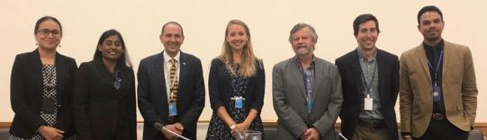
Panelists of the DOSI, UNESCO-IOC, Maldives side event, including DOSI delegates Harriet Harden,Davies, Paul Snelgrove & Jeff Marlow.

- Conference Report: DOSI’s report on IGC1.
- Summary of the conference published in DSM Observer, authored by Harriet Harden-Davies.
January 2019
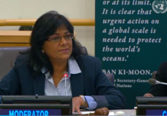
- Multi-stakeholder dialogue and capacity-building partnership event, UNHQ, NY. Judith Gobin attended for DOSI (funded by Arcadia) and made a DOSI intervention to engage more developing country delegates in deep-sea issues and provision of assistance. (Image: Judith Gobin at the UN).

- BBNJ Workshop, Fiji, hosted at the Pacific Islands Forum. Harriet Harden-Davies attended and provided four expert presentations, on marine genetic resources, capacity building, and the UN Decade of Ocean Science.

February 2019
- BBNJ Meeting, Ottawa, Canada. This invite-only meeting was attended by Harriet Harden-Davies, Kristina Gjerde & Paul Snelgrove, all of whom presented DOSI policy briefs. Attendance was useful in further developing relations with UN government delegates.

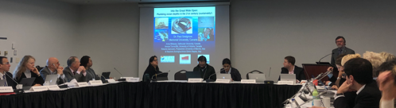
Paul Snelgrove presenting in Ottawa

March/April 2019
- DOSI participation in BBNJ IGC2. DOSI received a great deal of positive feedback from Member States about our constructive and evidence-based statements.
  - DOSI Delegation: Harriet Harden-Davies led the delegation and coordinated inputs from the BBNJ working group as well as the delegation of eight: Aria Finkelstein (MIT, USA), Muriel Rabone (NHM, UK) Jane Collins (Uni Leuven, Belgium), Paul Snelgrove (Memorial Uni, Canada), Jeff Marlow (Harvard, USA), Diva Amon (NHM, UK) & Porter Hoagland (WHOI, USA).
  - Side-Events/Workshop: DOSI took part in four side-events and one workshop in collaboration with partners:
    - "Facilitating Capacity Development, Transfer of Marine Technology and Ocean Science in BBNJ" IOC; DOSI; 27/03/2019. Muriel Rabone presented the policy brief
    - "Mare geneticum and an ecosystem approach: power, openness and sharing" IUCN; DOSI; University of Aberdeen; 28/03/2019. Muriel Rabone presented the policy brief
    - "Conservation, Climate Change and Ocean Biodiversity Beyond National Jurisdiction" Papua New Guinea, Belize, Federated States of Micronesia, DOSI 29/03/2019. Diva Amon presented the policy brief
    - “Pacific SIDS Regional BBNJ Workshop” Scandinavia House, 30/03/2019. Harriet Harden-Davies presented
    - "The Role of Science and a Scientific Body Under the New Instrument" Canada, High Seas Alliance, DOSI. Harriet Harden-Davies presented
  - Policy Briefs: DOSI produced, published and widely disseminated two policy briefs pre-, during, and post-IGC2 through government, IGO and NGO networks (referred to on the floor in statement from Barbados):
    - The Full Value of Marine Genetic Resources - This brief highlights how marine genetic resources, derived from the immense biodiversity of the ocean, not only represent an alluring potential source of fundamental scientific discovery and commercial bioproducts, but also provide an integral part of the global systems that make Earth habitable.
    - Accessing and Sharing Benefits from MGR from ABNJ - This brief highlights how best-practice approaches to marine scientific research already enable benefit-sharing from marine genetic resources by providing open and facilitated access to data and samples; a new BBNJ agreement could streamline and strengthen these approaches.
  - Interventions: DOSI delivered three interventions, based on the policy briefs (Intervention 1, 2 & 3).
  - Side-Meetings: DOSI engaged in several side meetings with delegates and provided ad hoc informal advice to raise awareness of:
    - Inter-linkages between climate change and BBNJ
    - The role of deep-ocean science and scientific best practices
  - A summary of the conference was published in the DSM Observer, co-authored by Aria Ritz Finkelstein and Jeffrey Marlow.

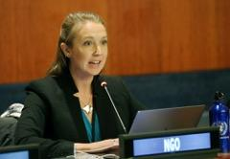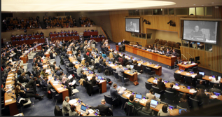
Harriet Harden-Davies delivering a DOSI intervention at IGC2. (Photo credit: ENB-IISD).

May 2019
- European Commission Workshop: Marine Genetic Resources – Bridging policy, law, science and research development Workshop, Brussels, Belgium. DOSI BBNJ and Deep-Sea Genetic Resources working group members attended this meeting and Muriel Rabone presented DOSI policy briefs. Link to report.

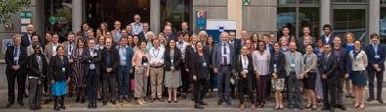
MGR Workshop participants, May 2019

June 2019
- UN Informal Consultative Process (ICP) on “Ocean Science and the United Nations Decade of Ocean Science for Sustainable Development”. DOSI was represented during this meeting by Harriet Harden-Davies and Kristina Gjerde who highlighted the deep pelagic (along with scientists from WHOI) and discussed capacity building and technology transfer. Diva Amon presented during the plenary panel on deep-sea science. Report. This enabled DOSI to once again build good relations at the UN.

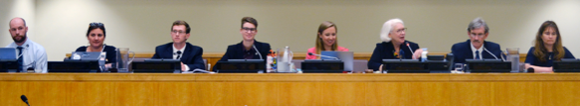
Harriet Harden-Davies and Kristina Gjerde are joined by colleagues from Woods Hole Oceanographic Institute and SEA at the UN-ICP meeting. (Photo credit: ENB-IISD).

August 2019
- Harriet Harden-Davies and Jeff Marlow coordinated input from the DOSI working group to produce a commentary on the first draft text of the BBNJ agreement.
- DOSI participation in IGC3. DOSI was in a strong position to provide input to this process, having built respect from fellow delegates who recognize the scientific credibility of our inputs. As an example, feedback on the DOSI BBNJ commentary on the draft BBNJ text was received in advance of this meeting from IGOs and NGOs. It is also notable that several of the issues that were raised in the DOSI commentary and relayed to delegates during in-person interactions were raised during Member State interventions. This included:
    - Scientific clarity no legal terminology relating to genetic resources
    - Stewardship
    - Intrinsic value of biodiversity, full value of marine genetic resources & the full environmental, social, and scientific value of biodiversity
    - Collaboration in capacity building
    - Deoxygenation
  - DOSI Delegation: Harriet Harden-Davies coordinated inputs from the BBNJ working group as well as the delegation of seven: Aria Finkelstein (MIT, USA), Muriel Rabone ( NHM, UK) Jane Collins (Uni Leuven, Belgium), Jeff Marlow (Harvard, USA), Erik Cordes (Temple Uni, USA), Judith Gobin (UWI, Trinidad & Tobago).
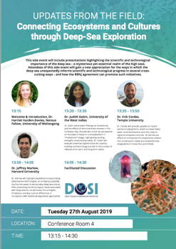
  - DOSI Side-Event: This DOSI event entitled “Updates from the field – Connecting ecosystems and cultures through deep-sea exploration” attracted more than 60 attendees and prompted good discussions among delegates regarding new technologies and capacity development.
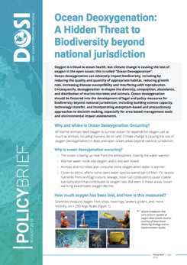
  - Policy Brief: A DOSI policy brief entitled “Ocean Deoxygenation: A Hidden Threat to Biodiversity beyond national jurisdiction” was produced for this meeting and widely circulated as, to date, the issue of deoxygenation in the deep ocean has been overlooked in the negotiations.
  - Engagement: DOSI participated in:
    - NGO coordination meetings
    - GOF and G77 “friends of CB and TT” meeting
    - Several side-meetings with delegates from states, NGOs and IGOs

DOSI activities - Deep Seabed Mining
During this reporting period, the DOSI Minerals working group, led by Drs. Diva Amon and Hiroyuki Yamamoto have once again provided crucial scientific input to the formulation of regulations for the exploitation of deep seabed minerals. It should be noted that in August 2019, Hiroyuki Yamamoto stood down as co-lead for this group owing to other pressing commitments and has been replaced by Dr Sabine Gollner (Royal Netherlands Institute for Sea Research). We are delighted to welcome Dr Gollner as she has in-depth knowledge of deep-seabed mining environmental issues, as well as has conducted extensive research on the ecology of deep-sea communities and their responses to disturbance events. Most of Sabine’s work has focused on hydrothermal vents and she is passionate about imparting scientific knowledge to advise the best possible management of potential future deep-sea mining, in line with DOSI goals.

There are currently 175 members associated with this working group which provides a focal point for scientific expertise and network engagement on deep seabed mining issues. The main activities of the Minerals working group in this reporting period are listed here in chronological order:

August 2018
- DOSI Minerals working group members attended and contributed to “Pelagic Effects of Deep-Sea Mining” workshop at the University of Hawaii (Aug 27-30). A comprehensive report from the meeting is available online.

September 2018
- DOSI Minerals working group members provided comment on the ISA Draft Exploitation Regulations, September 2018.

October 2018
- October 2018: DOSI Minerals working group members attended the Blue Economy conference, Nairobi, Kenya.

November 2018
- DOSI Minerals working group members attended the IASS Workshop, A Benefit Sharing Mechanism Appropriate for the Common Heritage of Mankind, Potsdam, Germany.
- DOSI Minerals working group members attended COP CBD, Sharm el Sheikh, Egypt.

February 2019
- ISA 25th Annual Session – 1st part. A DOSI delegation attended and presented during this session.
  - DOSI delegation: Jeff Drazen (Uni Hawaii), Julie Huber (WHOI, USA) Aline Jaeckel (UNSW, Australia), Verena Tunnicliffe (Uni Victoria, Canada), Philip Turner (Duke Uni, USA), Jessica Perelman (Uni Hawaii) and Diva Amon (NHM, UK).
  - Delivered a well-attended side-event entitled: New scientific knowledge to guide the environmental management and regulatory framework for deep-sea mining.
  - DOSI also made four interventions and held numerous side meetings during the session.

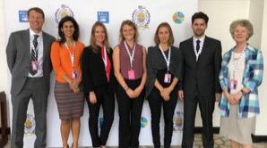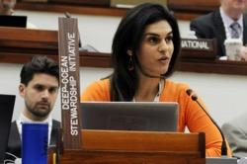
DOSI delegation at ISA, February 2019

- New paper as a result of DOSI 2018 workshop: Tunnicliffe et al. (2019). Strategic Environmental Goals and Objectives: Setting the basis for environmental regulation of deep seabed mining. Marine Policy.

May 2019
- ISA Workshop – Development of standards and guidelines for the mining code (15-19, Pretoria, South Africa). Invitation from ISA to DOSI to give presentation – Science in Standards Development (presented by Amber Cobley), and to sit on the closing panel discussions. Diva Amon also attended for DOSI.

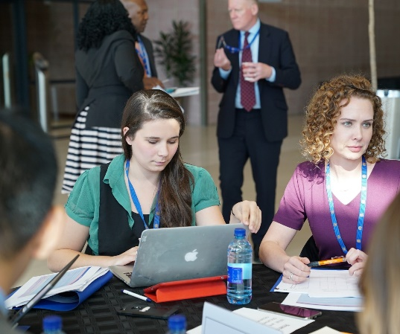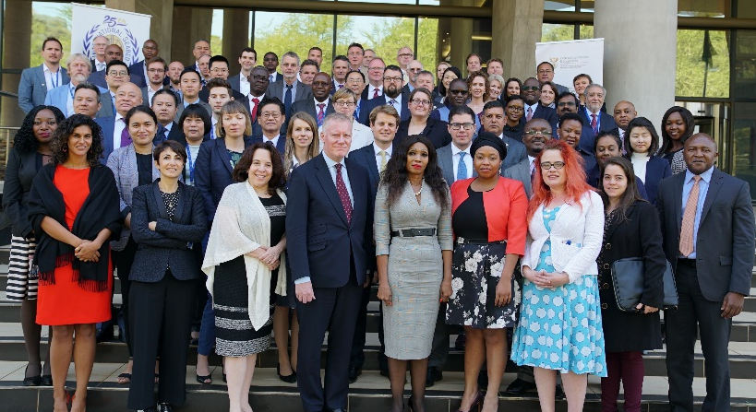
Amber Cobley (left) during breakout discussion session and Pretoria workshop participants

- DOSI Minerals working group members provided comment on the ISA Draft High Level Action Plan, May 2018.
- DOSI submitted a proposal to the ISA Endowment fund for DOSI workshop entitled “National capacity development in deep-sea environmental science and management in the South Pacific region”.

June 2019
- Deep-Ocean Climate Connections Workshop (Scripps Institution of Oceanography, California). Many DOSI Minerals working group members took part in this workshop where participants came together to discuss how climate change may interplay with the impacts of deep-sea mining, as well as where climate issues could be incorporated into the Mining Code. A policy brief was produced as a result of this workshop, which was presented and disseminated at the 25th Session of the ISA. There will also be a forthcoming paper. This workshop was funded by the JM Kaplan fund.

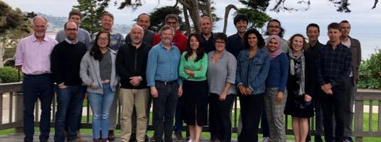
Participants of Deep-Ocean Climate Connections Workshop

- DSCC DSM strategy meeting (24 June, London). Diva Amon attended for DOSI.

July 2019
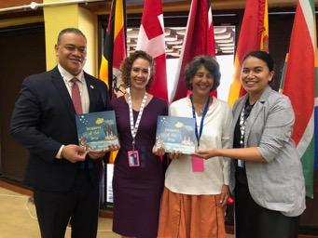
- DOSI Minerals WG members Maria Baker, Eva Ramirez-Llodra (NIVA, Norway/REV Ocean), Ana Hilario, Anna Metaxas (Dalhousie University, Canada) and Hannah Lily (Commonwealth Secretariat, London) produced an educational book for children on the subject of deep-sea mining entitled Treasures of the deep. This is intended as a balanced and thought-provoking illustrated book. It is available online as an ebook and pdf and is being distributed in hard-copy to developing nations with mineral resources. Hard copies were also distributed to delegates during the ISA 25th Session. It is currently being translated by volunteers into Spanish, Japanese, Portuguese, Italian, Indian and Tongan. The book was part-funded by the Commonwealth Secretariat. (Image: Presentation of Treasures of the Deep to the Tongan Delegation by Anna Metaxas – co-author - and Alison Swaddling of Commonwealth at ISA).

- ISA 25th Annual Session – 2nd part. A DOSI delegation attended and presented during this session.
  - Delegation: Diva Amon (Trinidad and Tobago/UK), Lisa Levin (USA), Anna Metaxas (Canada), Sergio Cambronero (Costa Rica) and Maila Paisano Guilhon (Brazil) participated in the Council Session (15-19 July), and Diva Amon, Pradeep Singh (Malaysia/Germany) and Eulogio Soto (Chile) were in attendance for the Assembly Session (22-26 July). There were also a number of other DOSI Minerals WG members present, but with other delegations.

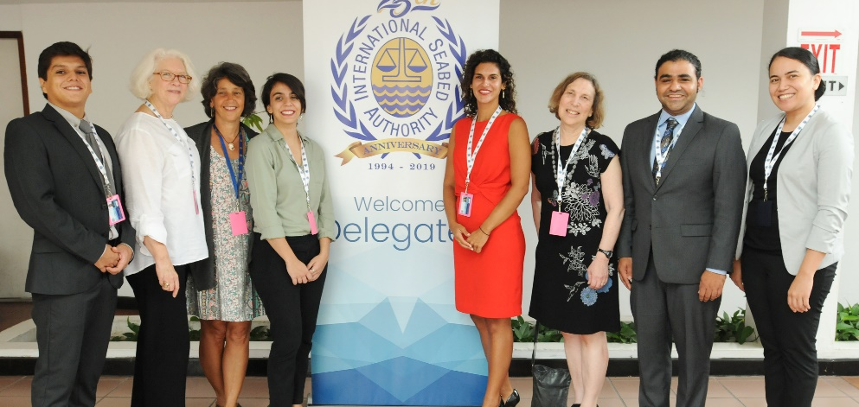
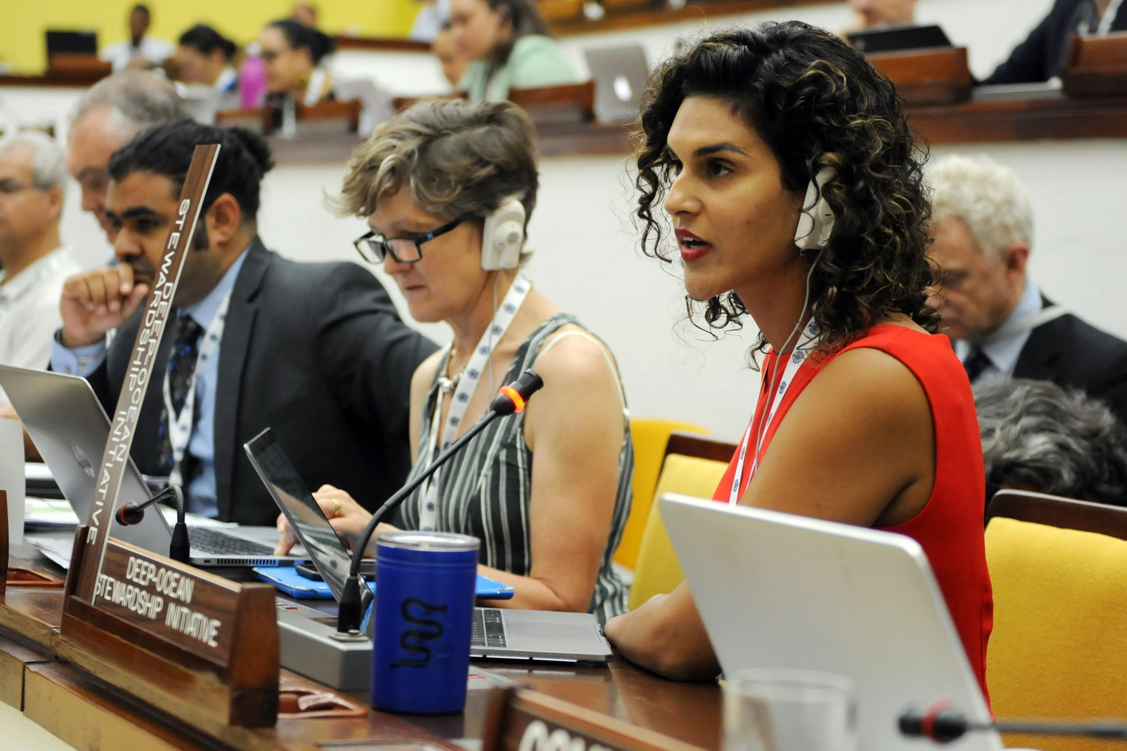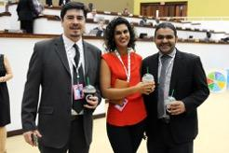
DOSI ISA Delegation, July 2019

  - Eight interventions were made by DOSI on a range of scientific and environmental matters.
  - Four policy briefs were disseminated, two of which were new: Diving deep into biodiversity & Climate Change Considerations are Fundamental to Sustainable Management of Deep-Seabed Mining.
  - DOSI co-hosted a side event, ’New Science in the Area’, with Pew Charitable Trusts on 18 July, that featured talks by Matthias Haeckel, Lisa Levin and Andrew Thaler.
  - Diva Amon delivered a presentation on scientific tools that may be useful to the ISA Inspectorate at the all-day Pew-RESOLVE event on 20 July. Lisa Levin and many other DOSI Minerals working group members were in attendance.
  - A number of productive meetings were held with ISA representatives and State Delegates throughout the two weeks by the DOSI delegation.
  - DOSI Minerals working group member, Mauricio Shimabukuro from Brazil, nominated by DOSI, named the second winner of the ISA Secretary General’s Award for Excellence in Deep-Sea Research.

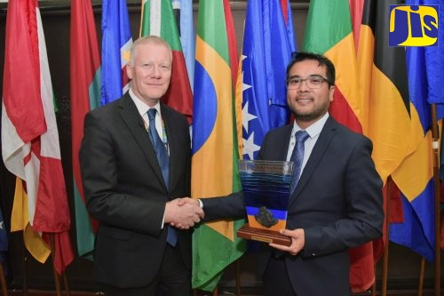
Mauricio Shimabukuro accepting ISA award

  - A summary of the ISA Session has been produced by the Earth Negotiations Bulletin.
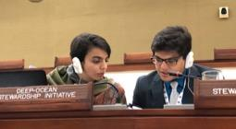
  - Participation of the DOSI delegation was supported by the Benioff Ocean Initiative and the JM Kaplan Fund. We worked to ensure that we invited and funded DOSI members from developing countries, including Eulogio Soto, and early career researchers Maila Paisano Guilhon e Sa (Brazil) and Sergio Cambronero (Costa Rica). Their reports are available online with praise for DOSI. (Image: Maila Paisano Guilhon e Sa and Sergio Cambronero at the ISA).
  - DOSI Minerals working group members (Diva Amon, Maria Baker, Sabine Gollner, Travis Washburn) made a video contribution to the ISA 25th Anniversary Celebrations.
  - The ISA DeepData database that houses all environmental data submitted by contractors was launched during the Session and is now being investigated in terms of quality and quantity by members of the DOSI working group.

August 2019
- Contributions from Minerals working group members to the latest version of the ISA Draft Exploitation Regulations are being compiled and will be submitted to the ISA in October 2019.

DOSI Activities – Climate Change
The DOSI Climate working group has continued to collaborate with UN agencies and other DOSI working groups in the areas of seabed mining, bottom fishing, biodiversity policy and climate policy to draw attention to climate change issues in the deep ocean and the need for conservation measures. There are currently 68 members associated with this working group which provides a focal point for scientific expertise and network engagement on climate change in the deep ocean. Listed below are the main activities from this working group in the past year:

September 2018
- Workshop “From COP21 towards the UN Decade”, UNESCO HQ, Paris (10-11 September). DOSI members (Lisa Levin, Nadine Lebris, and others) put forward DOSI climate messages via contributions to the poster session. Deep Thinking: Incorporating Climate into Ecosystem-Based Research and Management of the Deep Ocean and Vice Versa.
- Production of Climate and biodiversity beyond the limits of national jurisdiction policy brief circulated during September 2018 BBNJ negotiations, NY.

November 2018
- DOSI mentioned at high-level panel – Science for Ocean Actions – Bergen, Nov 20 by DOSI member Rebecca Ross.

December 2018
- UNFCCC COP24, Katowice, Poland (3-14 December). Exhibit booth on Ocean Observing. Deep-Ocean Observing Needs: Climate Science-Industry-Policy Nexus (Press Conference). Ocean Deoxygenation : Hidden climate impacts transforming our Ocean (Press Conference). Attended by Lisa Levin, Yassir Eddebar.

January 2019
- DOSI Climate working group member contributions to IPCC special report on oceans and cryosphere in a changing climate (SROCC) second order draft government and expert review (update of findings since 2014).

April 2019
- Revelle Commemorative lecture 2019 (Lisa Levin): Sustainability in Deep Water: The Challenges of Climate Change, Human Pressures and Biodiversity Conservation. Link here.

May 2019
- Lisa Levin Ocean Visions 2019 meeting, Georgia, USA.

June 2019
- New paper produced: Levin, L.A. 2019. Sustainability in deep water: The challenges of climate change, human pressures, and biodiversity conservation. Oceanography 32(2):170–180
- Workshop – Deep Ocean Climate Connections with Seabed Mining, Scripps Institution of Oceanography, USA. See below for associated policy brief.

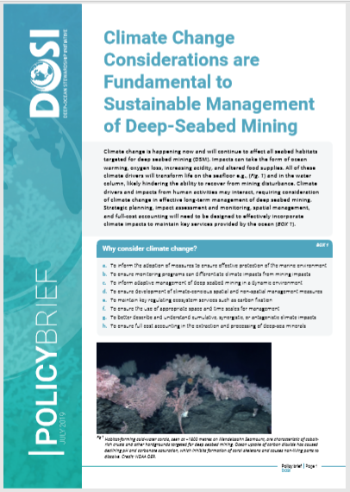
July 2019
- July 2019: DOSI climate change policy brief related to deep seabed mining: Climate Change Considerations are Fundamental to Sustainable Management of Deep-Seabed Mining (July 2019).

August 2019
- DOSI climate change policy brief related to BBNJ: Ocean Deoxygenation: A Hidden Threat to Biodiversity beyond national jurisdiction
- IPCC Special Report on Oceans and Cryosphere in a Changing Climate. DOSI members have participated in the development of this report, which was released on 25th September 2019.

Activities of other DOSI Working Groups
This report focuses on the BBNJ, Minerals and Climate working group progress and activities as these are the main interest areas for Arcadia Fund with regards to this funding allocation. However, the other DOSI working groups and the DOSI Office, Executive Team and Advisory Board have also been productive during this period and some of these activities are listed below for interest (in chronological order):

September 2018
- DOSI Executive Meeting
- In conjunction with the 15th Deep-Sea Biology Symposium (Monterey Bay, California, USA), DOSI held a “DOSI Day” on 9 September which was attended by 140 participants. The meeting participants “DOSI Updates and Deep-Sea Science Priorities for Ocean Health” reviewed DOSI activities and discussed future plans in breakout groups. A particular focus for the plenary was the UN Decade of Ocean Science for Sustainable Development and the deep-sea community contributions to this process. A key outcome from the workshop was the identification of major science-policy issues on which DOSI could contribute to the development of new regulations. DOSI secured funding from the International Seabed Authority to enable participation from five scientists from developing nations for DOSI Day and the Deep-Sea Biology Symposium.

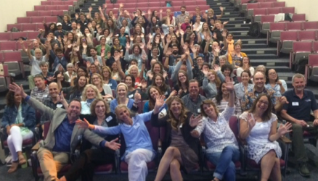
Some of the DOSI Day 2018 participants, Monterey Bay, USA

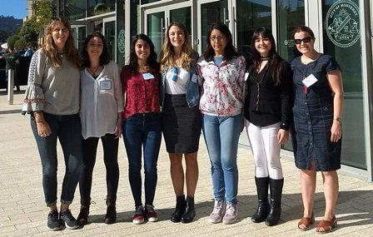
ISA awardees from developing nations (between Maria Baker and Rachel Jeffreys)

- DOSI Special Session. As part of the 15th Deep-Sea Biology Symposium, DOSI held a special session, chaired by Maria Baker and Lisa Levin, with talks across a range of subjects relevant to DOSI goals.
- DOSI sub-group formed to work towards a community consensus on designating Vulnerable Marine Ecosystems (VMEs) from imagery. Paper underway and abstract submitted for presentation at Ocean Sciences, Feb 2020. Group lead is Amy Baco, Florida State University, USA.
- Harriet Harden-Davies interviewed for Science, ‘UN Talks to tackle tough question: who should benefit from DNA collected from the high seas?’ Science, 3 September.
- Harriet Harden-Davies interviewed for New York Times, ‘What 13,000 patents involving the DNA of sea life tell us about the future’, New York Times, 17 September.
- Harriet Harden-Davies, Kristina Gjerde and Diva Amon were panelists on television show 'TRT World roundtable': “High Seas: relief to troubled water” 1 October 2018

October 2018
- DOSI involvement with art – Maria Baker participated in voice over for artistic piece related to deep-sea mining and the Common Heritage of Mankind (to be premiered in November 2019).
- DOSI submitted an expression of interest to the Intergovernmental Oceanographic Commission to participate in the UN Decade of Ocean Science for Sustainable Development.

October 2018
- 1st DOSI Decade working group meeting, Aveiro, Portugal. Started work on Decade position paper.

November 2018
- Royal Society meeting discussion meeting (12-13 November) “Beyond Challenger: a new age of deep-sea science and exploration”. Significant organisation and chair input from DOSI Core Team members.

December 2018
- DOSI lecture at University of Southampton (Maria Baker).
- Nobel Week talk and panel discussions by Diva Amon, mentioning DOSI.
- Deep-Sea Life Issue 12 produced and published.

January 2019
- Publication in Eco Magazine: Grand challenge for the deep – Levin & Baker.

February 2019
- Publication of: FAO. 2019. Deep-ocean climate change impacts on habitat, fish and fisheries, by Lisa Levin, Maria Baker, and Anthony Thompson (eds). FAO Fisheries and Aquaculture Technical Paper No. 638. Rome, FAO. 186 pp. Licence: CC BY-NC-SA 3.0 IGO.).

March 2019
- Judith Gobin & DOSI Oil and Gas working group lead, Erik Cordes, attended Oil and Gas conference at the University of the West Indies.
- Deep-Sea Genetic Resources and BBNJ circulated a survey to working group members
- DOSI Core Team meeting via Zoom (14 March).
- Jane Collins promotion of DOSI at Partnership for Regional Ocean Governance meeting, Ecuador. Science for solutions.
- Fisheries working group member Ashley Rowden (and others) attended FAO workshop on vulnerable marine ecosystems (VMEs) for the SIOFA region, National Research Institute of Fisheries Science, Yokahama, Japan, 18-19 March. Presented: Mapping VMEs: FAO DSF Guidelines and actions taken by RFMOs in other regions. First Meeting of the Protected Areas and Ecosystems Working Group (PAEWG1).

April 2019
- DOSI Decade position paper entitled: Deep-Sea Research in the Decade of Ocean Science. Mapping the role of the deep ocean in human society. Submitted to IOC.
- DOSI Core Team meeting via Zoom (30 April).

May 2019
- DOSI Decade working group members invited to 1st Global Ocean Decade Planning Meeting, Copenhagen, Denmark, May 13-15, 2019. 1st Global Ocean Decade Planning Meeting Report – Kerry Howell. Official GPM Summary Report. DOSI now recognised as IOC partner organisation and invited to attend IOC assembly, Paris.
- DOSI represented by Tammy Horton and Helena Wiklund at “Deep-Sea Taxonomy Under Pressure” meeting, Frankfurt (8-10 May). A taxonomy promotional video is under development.
- FAO Deep-Seas meeting, Italy (7-9 May). Lisa Levin presented DOSI FAO report.

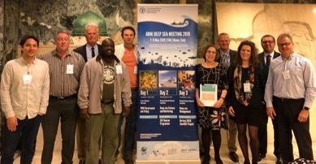
Lisa Levin and others at FAO Deep-Seas meeting, Italy

- Angelika Brandt presented DOSI slides at BMBF FONA meeting, Berlin (Research for sustainable development – Germany GEOMAR).
- OceanObs white paper - DOSI co-authored a paper on Blue Economy examples: Wenhai L, Cusack C, Baker M, Tao W, Mingbao C, Paige K, Xiaofan Z, Levin L, Escobar E, Amon D, Yue Y, Reitz A, Neves AAS, O’Rourke E, Mannarini G, Pearlman J, Tinker J, Horsburgh KJ, Lehodey P, Pouliquen S, Dale T, Peng Z and Yufeng Y (2019) Successful Blue Economy Examples With an Emphasis on International Perspectives. Front. Mar. Sci. 6:261.
- Harriet Harden-Davies authored: “Sharing benefits from genetic resources and sustaining the high seas” The Geographer, 2019, available p29.

June 2019
- DOSI invited to attend Commonwealth Blue Charter Partners Day, 20th June. Diva attended and presented the importance of science in policy for DOSI.
- Kristina Gjerde, Harriet Harden-Davies and Elva Escobar took part in the “Ocean Science and the UN Decade of Ocean Science for Sustainable Development” UNHQ New York, Meeting. DOSI held a side-event with IUCN & WHOI on 12 June entitled: Traditions, tools and technologies for advancing ecosystem-based management for the global ocean.
- Re-launch and dissemination of Message in a Bottle book (online and hard copies funded by Commonwealth Secretariat).

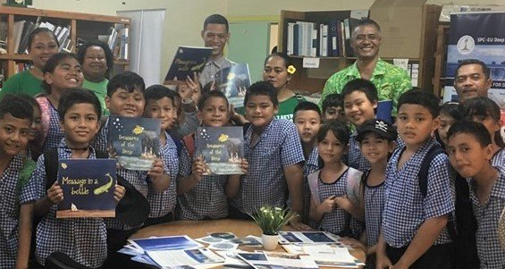
Children reading Message in a Bottle, Samoa

- Deep-Sea Life Issue 13 produced and published.

July 2019
- DOSI provides community liaison between programmes, agencies, organisations, individuals and other entities to translate and communicate research, data and expertise needs for actions that improve sustainability of the deep ocean. In addition to our regular communication via email (community-wide, specific working group and Core Team mailing lists), website, Twitter (followers have almost doubled since July 2018 to 1654), and publications (including Deep-Sea Life Newsletter), 2019 has seen improvements in terms of communications via a new DOSI website and the establishment of a DOSI Instagram account (240 followers to date). The new DOSI website production was funded by a grant from Synchronicity Earth and developed by TASON in conjunction with the DOSI Office who provided an extensive briefing outlining our desires. We wanted to achieve a more up-to-date website with improved flow, clear and concise content and ease of navigation for users. The feedback from the community regarding this new layout has been excellent.
- Two online meetings were held to discuss the finer details of the DOSI Decade science plan. Minutes DOSI Decade Meeting July 2019.
- In addition to DOSI observer status at the BBNJ and ISA, the University of Southampton (UoS), driven by Maria Baker, has recently applied for observer status at UNFCCC in advance of COP26 (2020) in the UK. DOSI hopes to be able to join the UoS delegation in order to ensure that the deep sea is considered during this key meeting.
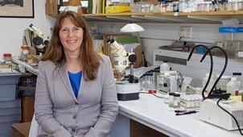
- Updates to the DOSI & INDEEP section of the University of Southampton MOOC were made this summer. The course entitled “Exploring the World’s Oceans” has recently completed its 10th run and remains popular on the FutureLearn platform. In total, more than 40,669 learners signed up to the course in 183 of 195 countries around the world. (Image: Maria Baker – University of Southampton MOOC).

Ongoing Activities
- Updates to DOSI bibliographies for deep-sea mining literature and deep-sea climate change publications.
- Production of a new academic book entitled: Natural Capital and Exploitation of the Deep Sea (Baker, Ramirez-Llodra & Tyler Eds). Due for completion December 2019 for publication ~June 2020.
- DOSI continues to provide letters of support for research that is in line with our DOSI mission and will help fill crucial knowledge gaps in deep-sea biodiversity research. The procedure for this has been updated and as a result, further information is requested from the scientists, which is then submitted to the DOSI Advisory Board members for approval in advance of a DOSI endorsement.
- DOSI Core Team members continue to explore and build new collaborations with those who have goals in-line with DOSI, some of whom could be potential funders (e.g. UK FCO, Commonwealth Blue Charter, Tara Ocean Expeditions, REV Ocean, OceanArchive, Gallifrey Foundation).
- Work is underway by DOSI Deep-Sea Tailings Disposal working group to contribute to a global standard for DSTD, which will include guidance on both the studies required to assess a potential DSTD activity, the requirements for design and location of DSTD operations and the requirements for management and monitoring of DSTD operations during and after the mine life. Collaborations with industry and the GESAMP working group on impacts of wastes and other matter in the marine environment from mining operations are underway.
- DOSI continues to encourage experts from the deep-sea science community to engage with important marine global assessments (e.g. IPBES and UN World Ocean Assessments) to ensure the deep ocean is well-represented in these key documents for the future.
- For the DOSI New Technologies working group, work continues on the development of software to bridge the gap between high quality video data collected in situ and currently available cloud-based image annotation tools, as well as on easily implementable protocols for meta-barcoding analyses of deep-sea meiofauna.
- Information sharing and discussions regarding deep-sea fisheries are facilitated by the DOSI Fisheries working group with a view to instigating specific activities for this working group in the future.

Additional Funding Secured
In line with our Arcadia funding T&Cs, we have informed Arcadia as and when DOSI has secured funds alongside those from Arcadia in order to enhance our work. Below is a summary of the funding received during this period and we continue to attempt to secure further funds for our activities:

- In March 2019, DOSI received a 3-year gift of $400,000 USD from Marc and Lynne Benioff to support DOSI’s vital science-policy engagement efforts, with a particular focus on deep seabed mining. These funds are administered at Scripps Institution of Oceanography with assistance from Lisa Levin and Diva Amon. With this support from the Benioffs, DOSI is providing further independent scientific input to the development of deep-sea-mining environmental regulations under the auspices of the International Seabed Authority, as well as increased expert presence at the negotiations for the development of a new treaty for biodiversity conservation in the 64% of the global ocean that lies in areas beyond national jurisdiction.
- The JM Kaplan Fund who have funded DOSI Minerals working group previously have awarded a further $60,000 USD (administered by the Scripps Institution of Oceanography, USA, led by Lisa Levin) for enhancing our interactions with the ISA and providing funds for workshops and workshop expenses.
- From August 2019, Maria Baker is now in receipt of a small amount of funding (£21,500 over 5 years) from the UK Global Challenges Research Fund (as part of the Once Ocean Hub programme) in order to enhance links with deep-sea research in Africa and DOSI goals.
- A funding award of £20,000 from Synchronicity Earth for enhancing DOSI communications (website, new communications strategy, emergency travel funds) was received in June 2019.
- Further to a DOSI proposal submitted in May 2019, the ISA Endowment Fund have agreed (in principle) to part-fund an educational science/policy workshop in 2020 (National capacity development in deep-sea environmental science and management in the South Pacific region) to a value of $60,000 USD.

Planned Future Activities September 2019 – August 2020
- BBNJ meetings. A DOSI delegation of scientists and ocean governance experts will attend the BBNJ IGC4, participate in discussions with delegates and preparatory workshops and develop new policy briefs on key issues for the next iteration of the treaty.
- Progression of new DOSI working group on Deep-Sea Debris and Pollution.
- Progression of work on DOSI VME imagery sub-group.
- New Advisory Board members will be in office for 2 years from May 2020 and are to be selected from our extensive master list of ~100 experts who have self-nominated for this role. In our selection, we aim to ensure a diverse range of team members in terms of gender, age, career stage, geographical location and viewpoints whilst maintaining excellence.
- Preparations are underway for a proposed DOSI special session at the World Conference of Marine Biodiversity, NZ, December 2020 (led by DOSI members Ashley Rowden and Malcolm Clark).
- Preparations for DOSI attendance at UNFCCC COP26, UK – December 2020.
- DOSI Minerals working group members are finalising a commentary on ISA draft exploitation regulations for submission in October 2019.
- ISA Meetings. DOSI will attend the February ISA session in Jamaica and the July session in Jamaica in 2020, where we will aim to deliver a further science-related side-event.
- DOSI aims to have strong representation at upcoming deep-seabed mining-related meetings and workshops (environmental aspects) (likely to number more than 8 meetings and workshops in the coming period including the ISA Workshop on Strategic Approaches to Developing Regional Environmental Management Plans, Germany (11-13 November 2019).
- Deep-Sea Life Issues 14 (November 2019) & 15 (June 2020) co-produced with INDEEP and the Deep-Sea Biology Society and distributed to the INDEEP-DOSI mailing list.

Are we on track?
DOSI has continued to make excellent progress in many areas during this second year of funding from Arcadia, as outlined above. As stated in our grant agreement with Arcadia, activities undertaken during the period 2018-2022 will build upon those that we have already completed in the first year. The nature of our priority focus areas sometimes makes it difficult to predict specific target dates for some elements as DOSI needs to be responsive to the new legal and policy developments and the evolving timelines associated with international negotiations. However, we have tried to capture what we believe will be some of our key activities for the 2019-20 reporting period in the section above. In addition, owing to our improved and more regular Core Team communications, we are achieving good integration between the different working group topics.

As you are aware, DOSI’s network model relies largely upon experts giving their time for free and securing funding for specific activities, including human resources to coordinate and deliver activities. Nevertheless, DOSI is on track to deliver more than the outputs proposed, in order to respond to the growing need for robust independent scientific input to governments, NGOs and IGOs that DOSI offers. We are confident that we are delivering all that we hoped to and more.

Impact
DOSI works to raise awareness among all deep-sea stakeholders about the importance of sustaining a healthy and productive deep ocean for long-term global ocean health. Through our efforts, we know that we are making progress. Impacts for this work are not always directly measurable, although here are some indicators of impact for this period:
- Side-events: 12 side-events with hundreds of participants - BBNJ & ISA
- Numerous interventions during policy sessions – BBNJ & ISA
- Inclusion in reported outputs from UN/ISA deliberations
- DOSI suggestions accepted into ISA draft strategic plan
- Invitations for DOSI representatives to contribute to policy-related meetings
- DOSI Publications (peer-reviewed papers, reports, workshop reports, 10 policy briefs, DOSI presentations, 2 stakeholder commentaries to ISA)
- Media attention
- DOSI Special Session
- DOSI Day attendance: 140
- Deep-Sea Life circulation – approx. 1800 deep-sea and marine science community members receive the link to this publication directly and it is further disseminated within institutions
- DOSI successful funding applications – 5
- Increased following in terms of DOSI network (687 members), Twitter (1654 followers) and new DOSI Instagram (240 followers)

New Publications
All open access and available on the new DOSI website.
- Levin, L & Baker, M. (2019) Grand Challenge for the Deep. Eco Magazine. Jan/Feb 2019
- Rabone, M et al. (2019) Access to Marine Genetic Resources (MGR): Raising Awareness of Best-Practice Through a New Agreement for Biodiversity Beyond National Jurisdiction (BBNJ). Front. Mar. Sci. 6:520. doi: 10.3389/fmars.2019.00520
- Thompson, A., Levin, L, Baker, M. (2019) DOSI/FAO Technical report – Deep-ocean climate change impacts on habitat, fish and fisheries
- Tunnicliffe et al. (2019) Strategic Environmental Goals and Objectives: Setting the basis for environmental regulation of deep seabed mining. Marine Policy
- Treasures of the Deep (Children’s book – ocean literature on deep-seabed mining)
- Wenhai, L, Cusack, C, Baker M, Tao W, Mingbao C, Paige K, Xiaofan Z, Levin L, Escobar E, Amon D, Yue Y, Reitz A, Neves AAS, O’Rourke E, Mannarini G, Pearlman J, Tinker J, Horsburgh KJ, Lehodey P, Pouliquen S, Dale T, Peng Z and Yufeng Y (2019) Successful Blue Economy Examples With an Emphasis on International Perspectives. Front. Mar. Sci. 6:261
- Harden-Davies, H. (2019) Sharing benefits from genetic resources and sustaining the high seas. The Geographer, available p29.
- Deep-Sea Life Issues 12 & 13

- Levin, L.A. (2019) Sustainability in deep water: The challenges of climate change, human pressures, and biodiversity conservation. Oceanography 32(2):170–180
- DOSI Policy Brief – Deoxygenation (August 2019). Climate/BBNJ Working Groups
- DOSI Policy Brief – Climate change considerations are fundamental to sustainable management of deep seabed mining (July 2019). Climate/Minerals Working Groups
- DOSI Policy Brief – Diving Deep in to diversity brief (Jul 2019). Climate/Minerals Working Groups
- DOSI Position Paper – Deep-Sea Research in the Decade of Ocean Science – Mapping the role of the deep ocean in human society (Apr 2019). Decade Working Group
- DOSI Policy Brief – Access and sharing benefits from marine genetic resources from ABNJ: building on best practices in the scientific community (Mar 2019). Marine Genetic Resources Working Group
- DOSI Policy Brief – The Full Value of Marine Genetic Resources (Mar 2019). BBNJ Working Group
- DOSI Policy Brief – Climate and biodiversity beyond the limits of national jurisdiction (Nov 2018). Climate and BBNJ Working Groups
- DOSI Policy Brief – Sustaining biodiversity beyond national jurisdictions: The major science challenges (Nov 2018). BBNJ Working Group.
- DOSI Policy Brief – Deep-Sea Fundamentals (Sept 2018)
- DOSI Policy Brief – Strategic Environmental Assessment (Sept 2018). BBNJ Working Group

