SONG OF THE OCEANS
“Science and art are natural friends: one often inspires the other. In this unique collaboration at the University of Aberdeen, Professor Marcel Jaspars (chemist) and Professor Abbe Brown (law) team up with ‘the nation’s favourite living composer’ Professor Paul Mealor and internationally acclaimed poet, Dr Grahame Davies to produce a ‘Song of the Oceans’.”

How to take part:
STEP 1: Watch the music videos and the choral backing tracks to Song of the Oceans. The backing tracks will also be listed at the end of the document.

STEP 2: Rehearse and record your submission as per the instructions below.

STEP 3: Upload your video submissions for ‘Song of the Oceans’ onto DropBox (link provided below)

PLEASE SUBMIT YOUR VIDEOS ONTO DROPBOX BY MONDAY APRIL 26th, AT 10:00 AM (GMT) 2021

How to create your recording space (at home)

- Please record your video in front of a plain wall or other plain background.

- Choose clothing without patterns or logos, as it can distort the video.

- If you can, record in a quiet room with the door closed to reduce unnecessary noise. Turn off appliances or anything that hums or is noisy.

- Please make sure your face is brightly lit. Use whatever lamps or natural light you have available to achieve this.

- If you have a tripod mount for your phone/camera, please use it or secure your camera in some other way to minimise movement.

Once you are happy that you have created your own recording space go to the next section named ‘How to record your video’.

How to record your video

- If you are using a smartphone/laptop, turn it to silent so your recording isn’t interrupted by a message or call.

- Please record your video horizontally (picture in landscape).

- Connect your headphones to the device you’re using to watch and listen to the backing track which will be playing. During the duration of YouTube clip you will hear two tracks, one on the left-hand side of your headphones which will be the orchestral backing track, and the second on the right-hand side of your headphones which will be the voice guide track to assist you in the recording of your track.

- Set-up and secure your second device to record your video. Make sure you record horizontally (landscape) and that your face is centred in the middle of the screen.

- If possible, please set your device to create an MP4 in 720p. Most smartphones create MP4s automatically and you can amend the resolution in your settings. We ask that if your video size is over 200MB, that you use a video compression tool here. If you need help recording and/or compressing your video, please get in touch.

- Start recording on your device and then press play on the backing track video. Remember to clap at the beginning when are prompted to clap on the video. This is very important as it will help us to sync your final audio and video.

- Please wait for approximately 10 seconds (in your head!) after you finish singing before you stop recording. Then save your video.

- Review your video and if you’re happy with your performance go to the next section on ‘Reviewing and Submitting’.

File Naming – IMPORTANT!

When you have saved and finished reviewing your video ready to upload onto DropBox it is important that you upload your videos in this format:

(the NAME OF THE PIECE-your PART-your FULL NAME-your LOCATION):

For example: SongoftheOceans-Bass-JoeBloggs-Berlin, Germany

This file naming method will not only ensure we know what part you have submitted, but also will allow us to credit all the different locations of the world that have been submitted.

Reviewing and Submitting

Once you are happy with your recording, here is a short step by step process of how to submit your video submission onto DropBox: Follow the steps below…

- Click on the link next to your respective voice part to upload your video:
Soprano: https://www.dropbox.com/request/jHeDSpv3EKTSkQNKZ3A1
Alto: https://www.dropbox.com/request/VEvsx9yzKc3i9IQNrNsC
Tenor: https://www.dropbox.com/request/eHKmAMoWeVO9I4lo9Da2
Bass: https://www.dropbox.com/request/Br5tdWfvxCnzIpxg3Z80
Signing Choirs: https://www.dropbox.com/request/jmclR1jIG90asYRUn2Cy
Singing Hands: https://www.dropbox.com/request/Ox03oHUSOUk5nCZdfNlD
Choir Ensembles: https://www.dropbox.com/request/nB7bpcVg7LaYsP5gsDOp

- Click on the ‘add files’ icon to add your video.
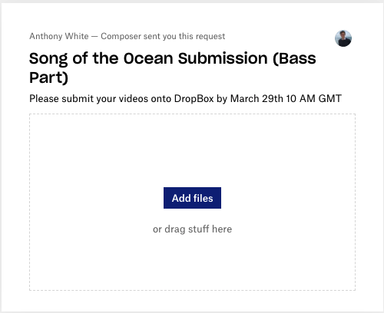
- Click UPLOAD.
- Complete!

Backing Tracks for Song of the Oceans

SOPRANO: https://youtu.be/3k4rhbZ7xdY
ALTO: https://youtu.be/EjL35Q8F4XM
TENOR: https://youtu.be/t12ixCKqcns
BASS: https://youtu.be/4lgb_KTCSvM

FULL BACKING TRACK: https://youtu.be/o5MoiLifecI

Referenced assets: cover image taken from Unsplash Photo by Tim Marshall on Unsplash

For more information about the Song of the Oceans project head to the DOSI website and follow DOSI on social media.

Thank you for participating in the Song of the Oceans global virtual project 2021!

